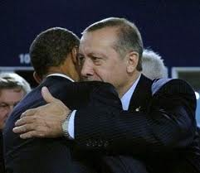Obama’s re-election has caused a major boost in confidence for countries like Britain and France in their wanting to topple Assad. But, it has also given confidence to Turkey, in their desire to oust out Assad; but the goal of the Turks is to conquer Syria, in order to revive the Ottoman empire. Photo above right is Obama hugging his favorite foreign leader, Turkey’s Islamist Prime Minister Erdogan.

Theodore Shoebat A little while back, I reported on the Turkish plan to revive the Ottoman empire, and that Syria will be a primary target for the expansion of their universal empire. Syrian Ambassador to Tehran Hamed al-Hassan, had this to say:

Turkey is trying to reconstruct the Ottoman Empire in the region … “When Turkey’s Justice and Development Party won the Turkish parliamentary elections, Turkish Prime Minister Recep Tayyip Erdogan presented his party’s victory to the people of Syria, Egypt, Morocco, Central Asia, and the Balkans which were once parts of the Ottoman Empire.
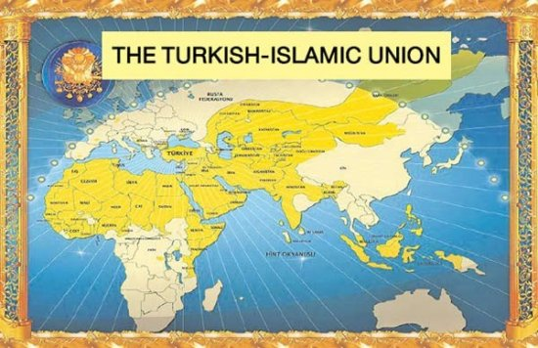
For over 500 years, the Turkish Ottomans ruled the Middle East, and in the years to come, they will arise once again as a regional superpower. The Islamic World is incapable of uniting voluntarily. It is, however, capable of being dominated by a Muslim power. Throughout history, Turkey has been the Muslim power most often able to create an empire out of the Islamic world. Turkish Prime Minister Erdogan has led the rapid Islamization of Turkey. This is the same Erdogan who actually spent time in jail, when Turkey was still a secular state, for the writing the following overtly radical poem: “The Mosques are our barracks, the domes our helmets, the minarets our bayonets, the believers our soldiers. This holy army guards my religion. Almighty our journey is our destiny, the end is martyrdom.”

Now with Obama re-elected, the Turks, England and France, will be pushing the U.S. more than ever to push for the ousting of Assad, with the help of NATO forces. That this is Obama’s second term makes this situation even more dangerous, because the president now has nothing to loose, since he does not have to worry about campaigning for a subsequent victory. His actions can be reckless, without the danger of not getting re-elected.

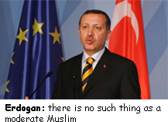

Expect to see Obama’s actions on the Middle East to be reckless, and the cause of chaos. We must expect to see the rise of Turkey following the future fall of Assad thanks to the U.S., Western allies, and NATO. With Assad gone, Turkey will then gradually take power over Syria.

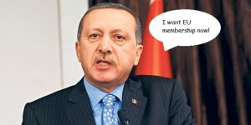Syria will be the first nation to go under Turkish rule because of its closeness, and the expediency of invading such a country, on account that Turkey is trusted by the West, and that Syria will voluntarily allow itself to be under the power of Turkey to fill its absence of a strong enough government. Though, I believe that before this occurs, Syria will be under the Muslim Brotherhood.

This will give rise to a Turkish superpower, which will ultimately expand throughout the Near East, which will pose a threat to the West and Israel. The fall of Syria, and the rise of Turkey will be the result of Obama’s re-election.
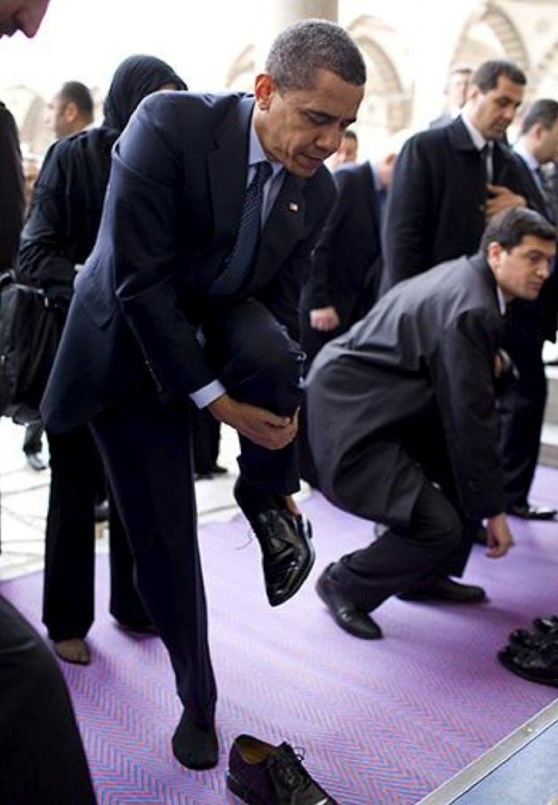
Obama removing his shoes at a mosque in Turkey in preparation to lift his ass in prayer to Allah, which he memorized when he attended a madrassa in Indonesia

Within hours of Obama’s second victory, Western allies had already designed a development for Syria, expecting a much more aggressive approach to Syria by the president. England and Turkey are already discussing the use of NATO against Bashar al-Assad, expecting more support from Obama.

British prime minister David Cameron stated that

There is an opportunity for Britain, for America, for Saudi Arabia, Jordan and like-minded allies to come together and try to help shape the opposition, outside Syria and inside Syria … And try to help them achieve their goal, which is our goal of a Syria without Assad.

Turkey is working with rebel groups, stating that NATO has discussed on using Patriot missiles to protect a supposed safe zone inside Syria.
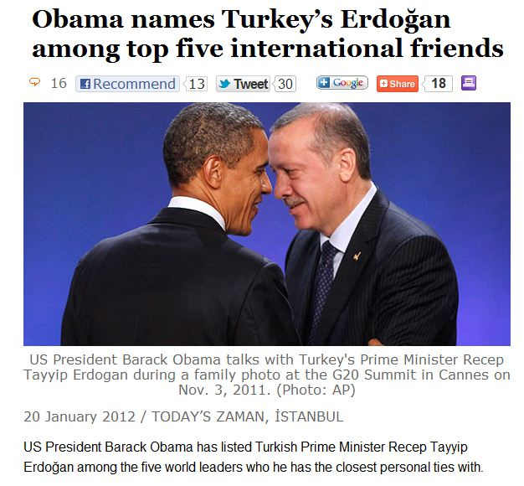

Shashank Joshi, an analyst at London’s Royal United Services Institute, a military and security think tank, made a statement indicating the confidence felt by Western forces in their plan to oust Assad, on account of Obama re-election:

With the re-election of Obama, what you have is a strong confidence on the British side that the U.S. administration will be engaged more on Syria from the get-go

According to British Foreign Secretary William Hague, American, British, French, and Turkish diplomats are already scheduled to meet with Syrian rebel groups in Doha, Qatar. David Cameron also said that he will press Obama to try and end the Syrian revolution.

As I have reported numerous times, the Syrian revolution is not peaceful, nor is it for the cause of peace and democracy, but for the establishment of a Islamic state in Syria, and primarily, for the configuring of a Caliphate.

